Steve Famiglietti

Storm Chaser
I am a storm chaser. I chase with a company called Silver Lining Tours. Tornadoes are rated using the EF Scale, F for Fujita, the gentleman who invented this scale. The rating goes from EF0 to EF5.
Fujita and the Enhanced Fujita Scale
The Fujita scale was introduced in 1971, but was decommissioned in 2007 being replaced by the Enhanced Fujita Scale which was then introduced in the United States. The chart below compares the wind speeds and categories each scale categorized from ratings zero through five.

Storm Chasing Data
As a storm chaser, I travel in vans across state lines all throughout the US. Safety is a huge priority, especially when you take into consideration the data below
Type of Tornado | EF0 percentage | EF1  percentage | EF2  percentage | EF3  percentage | EF4  percentage | EF5  percentage
United States Tornadoes | 62% | 26% | 8% | 2.5% | 1% | 0.5%
Interstate Tornadoes | 22.5% | 34% | 24% | 13% | 5% | 1%
Vehicle Impact Tornadoes | 13% | 35% | 26% | 16% | 9% | 1%

Joel
My dog’s name is Joel, he is from an organization called Guiding Eyes for the blind located in Yorktown Heights, NY.
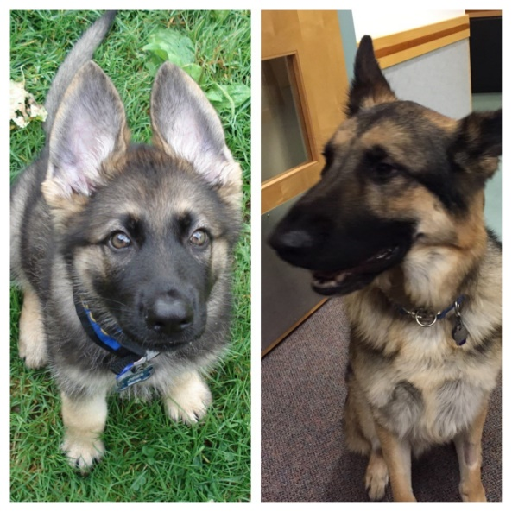
Guiding Eyes
Learn more about what they look for in a guide dog candidate here: https://www.guidingeyes.org/dogs-and-puppies/journey-of-a-guiding-eyes-dog/
Fidelco
He is 9 years old and we have been together since he was two years old. My first dog was from the Fidelco Guide Dog Foundation, located in Bloomfield, CT. Here is a message from their COO: https://www.fidelco.org/who-we-are---message-from-the-coo
Blind Services
Here at the NEAT Center at Oak Hill, I teach people to use products that can aid those with blindness and low vision.
Products for Low Vision:
*JAWS for Windows screen reading software
*OpenBook scanning and reading software
*ZoomText screen magnification software
Products for Blindness:
*Screen readers
**JAWS
**NVDA
*Braille notetakers
**BrailleNote Touch
**BrailleNote Touch Plus

