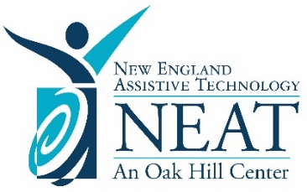
NEAT Center Services
for Cohort A

Cohort A Schools |  | Engagement Schedule
Andover  Barkhamsted  Bethel  Bolton  Bozrah  Colebrook  Cromwell  East Haddam  East Hampton  East Lyme  East Windsor  Eastford  Enfield  Glastonbury  Granby  Hartford  Hebron  Litchfield  Madison  Marlborough  Meriden  Montville  Naugatuck  New Canaan  New Fairfield  New Hartford  Newtown  Norfolk  Norwich  Plainfield  Plymouth  Preston  Putnam | Region 13  Region 14  Region 15  Region 16  Region 17  Region 18  Region 7  Region 8  Rocky Hill  Sherman  Simsbury  Southington  Stamford  Sterling  Thomaston  Voluntown  Wallingford  West Hartford  West Haven  Wethersfield  Windsor | 2022-2023  Membership  2023-2024  Subscription & Membership  2024-2025  Membership

More details on page 2.
NEAT Center Membership

Let’s dive into the details:

Learn More About Your Membership Benefits
NEAT believes the most sustainable quality assurance plan is one that grows organically within each school district. To support this growth, NEAT offers professional development events geared specifically towards the needs of school-based teams. This will provide new information about your subscription, explore best practices, and reinforce concepts for districts actively seeking to build their AT capacity.
- Visit NEAT’s website for more details

NEAT Membership includes:
- Pop-up Consultations
A monthly availability calendar is presented to NEAT Members so that they can sign up for one-hour virtual AT consultations with AT Specialists who offer unique areas of expertise (i.e., Blind/Low Vision, Communication, SLD/Dyslexia, etc.). This consultation can be flexible in its purpose to meet the desired needs of the team, supporting the need for quick access to information or troubleshooting that does not warrant a more formal request. This offers a low time commitment with the ability to pick a convenient date/time and receive immediate support with minimal paperwork.
- Lending Library
The NEAT Lending Library provides short-term loans (30 days) of assistive technology devices, including iPads and iOS apps, Chromebooks with Chrome extensions, alternative keyboards, eye gaze technology, and so much more. These devices can be borrowed to support the decision-making process, to serve as a short-term loan while a device is purchased or fixed, to incorporate into demonstrations during professional development opportunities, and/or to assist in school-led AT Evaluation trials. NEAT Members can also borrow AT tools to learn about their features for their own professional growth and capacity building purposes.
- Exclusive Webinars and Professional Development
The NEAT Center hosts an extensive list of online webinars, delivered by nationally recognized AT Specialists. These educational webinars demonstrate the most important trends and latest technology in early education, education, AAC, AT, and smart home solutions. NEAT Members are given access to live sessions aimed at helping to develop AT skills in short, personalized increments as well as archived, recorded webinars that could be accessed for self-paced learning. Access archived webinars with the Password: TeachMeAT
- AT Information and Resource
The NEAT Center is a resource for NEAT Members to provide quick turnaround and brief guidance around their individualized AT needs.
All new and returning Members can get started by signing up today!
Let’s Stay Connected!
Main Contact | Elena Hurlburt, M.A., CCC-SLP  Director of Assistive Technology Services  Elena.Hurlburt@OakHillCT.org
Website | https://assistivetechnology.oakhillct.org/
Twitter | @NEATwithRamon, @NEATwithLiz, @NEATwithJamie, @NEATwithElena, @NEATwithSteve, @NEATwithMargie, @NEATwithKristen

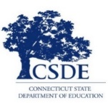
Your NEAT Membership has been generously sponsored by
The CT State Department of Education

