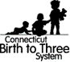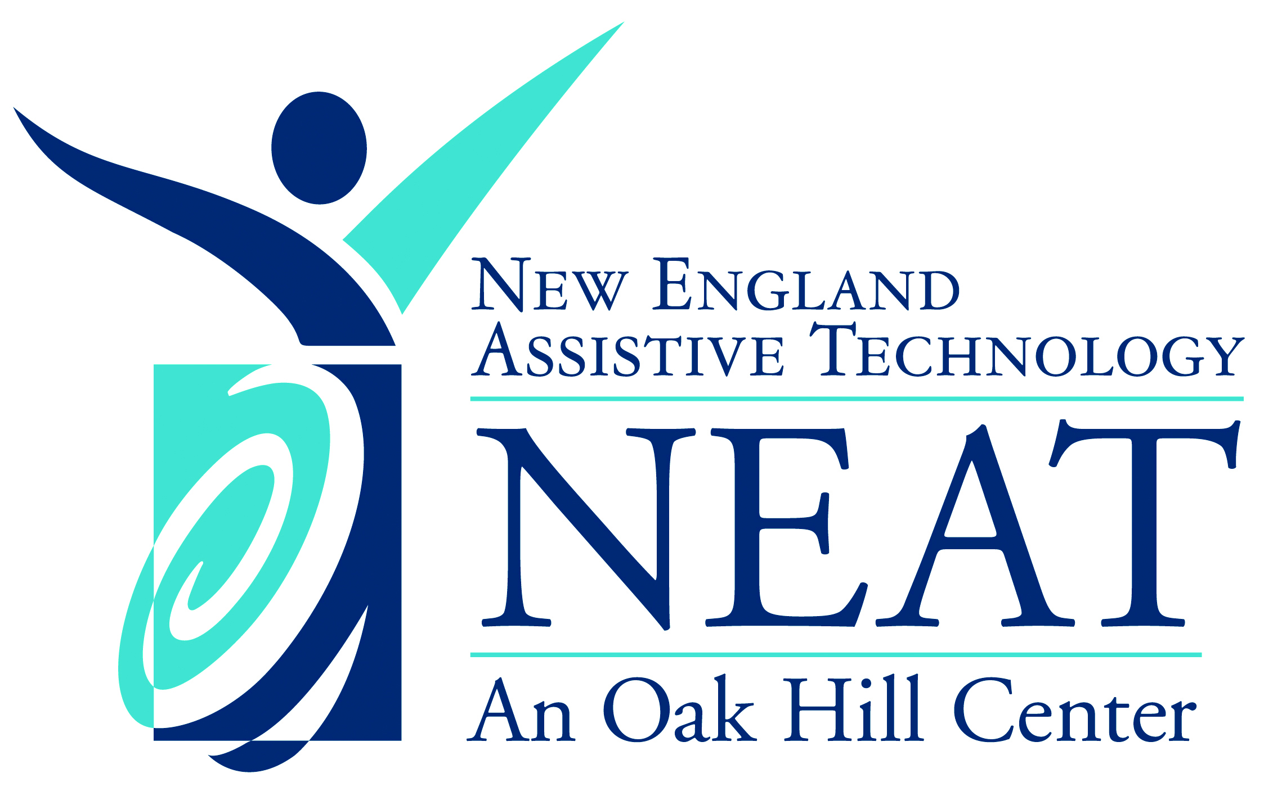

ASSistive technology Loan Agreement

(Form 3-14, Long term AT loan)

NEAT - Birth to Three Inventory provides long-term loans of Assistive Technology (Communication Devices and Adaptive Equipment) and iPads to provide connectivity for remote EI through the Governor’s Emergency Education Relief (GEER) fund.
Instructions (Refer to Birth to Three AT Procedure):
- Device must be returned to NEAT when no longer used
- Timeline for borrowing equipment is impacted by child’s age
- Child can keep the loaned device after exit from Birth to Three if it is still appropriate, it is being regularly used, and there is a plan for acquisition of the device through other means
- Inform family that NEAT will make follow-up phone calls/emails to see if device can be returned
- Family should contact NEAT if they no longer need the device, or moving out of state
- Request for AT must be made by staff from a discipline appropriate to the requested device (i.e. SLP for communication, motor therapist for large equipment)

RETURN FORM TO: NEAT.B23@oakhillct.org
Birth to Three Provider/Agency Contact Information
Today’s Date:
B - 3 Interventionist Signature (and Print Name):
Title/Role:
B – 3 Program:
Address:
Phone Number:
Email:
Birth to Three Family Contact Information
Child’s Name:
Child’s ID/Case #:
Child’s Birth Date:
Receiving EIS over Three? (Y/N):
Birth to Three Exit Date:
Parent/Guardian Name:
Address:
Phone Number:
Family Email:
Primary Language:
I would like to borrow the following from inventory at NEAT:
☐ iPad/Device for Communication
☐ iPad for access to Remote EI visits (GEER)
☒ Adaptive Equipment

Describe requested specific equipment/features/measurements or apps/accessories:

I would like to obtain this loan in the following way:
☐ By mail, to the program address listed above (ONLY for GEER iPads and Communication Devices)
☐ Pick-up, by the provider at 33 Coventry St. Hartford, CT 06112 (The NEAT Center)
☐ *Delivery by NEAT, to the program address listed above (ONLY available for adaptive equipment)
☐ *Delivery by NEAT, to the family address listed above (ONLY available for oversized equipment)
* Upon delivery of equipment, an interventionist MUST be available to sign as a representative of the Birth to Three Program. Equipment will NOT be left without a representative present.

NEAT USE ONLY (for Adaptive Equipment)
List Adaptive Equipment borrowed, including Inventory #:

Loan Start Date/Date Delivered:
Birth to Three Provider’s Signature (and Print Name):
NEAT Staff’s Signature:

